Implementation of Data Link Layer Framing Methods
Aim : To Write a c program to implement two stuffing techniques.
- Bit-stuffing
- Byte stuffing/Character stuffing

Character stuffing
- In the second method, each frame starts and Ends with the ASCII character FLAG.
- This method overcomes the drawbacks of the character count method. If the destination ever loses synchronization, it only has to look for FLAG characters.
- If however, binary data is being transmitted then there exists a possibility of the characters FLAG occurring in the data. Since this can interfere with the framing, a technique called character stuffing is used. The sender's data link layer inserts an ASCII ESC character just before the FLAG character in the data.
- The receiver's data link layer removes this ESC before this data is given to the network layer. However character stuffing is closely associated with 8-bit characters and this is a major hurdle in transmitting arbitrary sized characters.
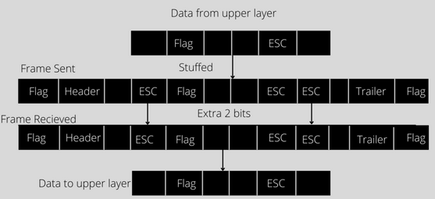
Algorithm:
Step1: Define FLAG and ECS character
Step2 : Rread the message
Step3: Scan the message looking for FLAG and ESC character in the message
If present insert ESC character
Step4: For destuffing scan the received message looking for ESC character in the message if present remove and read the next character.

Program:
#include <stdio.h>
#include<string.h>
#define FLAG '$'
#define ESC '@'
int main()
{
char data[25],stuff[50],dstuff[50];
int length,i,j;
printf("Enter the message");
scanf("%s",data);
length=strlen(data);
stuff[0]=FLAG;
for(i=0,j=1;data[i]!='\0';i++)
{
if(data[i]!=FLAG && data[i]!=ESC)
{
stuff[j++]=data[i];
}
if(data[i]==FLAG || data[i]==ESC)
{
stuff[j++]=ESC;
stuff[j++]=data[i];
}
}
stuff[j++]=FLAG;
stuff[j]='\0';
printf("Stuffed message is %s\n",stuff);
printf("destuffing the message\n");
length=strlen(stuff);
printf("length of stuff array is %d\n",length);
for(i=1,j=0;stuff[i]!='\0';i++)
{
if(stuff[i]!=FLAG && stuff[i]!=ESC)
{
dstuff[j++]=stuff[i];
}
if(stuff[i]==ESC)
{
i++;
dstuff[j++]=stuff[i];
}
}
dstuff[j]='\0';
printf("DeStuffed message is %s\n",dstuff);
return 0;
}
OUTPUT:
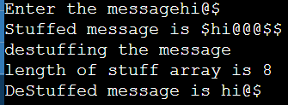

Bit stuffing
- The third method allows data frames to contain an arbitrary number of bits and allows character codes with an arbitrary number of bits per character.
- At the start and end of each frame is a flag byte consisting of the special bit pattern 01111110 .
- Whenever the sender's data link layer encounters five consecutive 1s in the data, it automatically stuffs a zero bit into the outgoing bit stream. This technique is called bit stuffing.
- When the receiver sees five consecutive 1s in the incoming data stream, followed by a zero bit, it automatically destuffs the 0 bit.
- The boundary between two frames can be determined by locating the flag pattern.
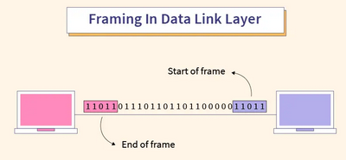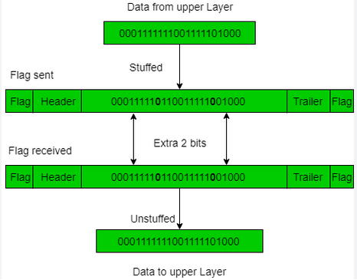
Program for Bit Stuffing.
#include<stdio.h>
#include<string.h>
char a[50];
char b[50];
char flag[8] = "01111110";

int main()
{
int i = 0, j = 8, n, k;
printf("Enter the message:\n");
gets(a);
strcpy(b, flag);

n = strlen(a);
for (k = 0; k < n; k++)
{
if (a[k] == '0' &&a[k + 1] == '1' && a[k + 2] == '1' && a[k + 3] == '1' && a[k + 4] == '1' && a[k + 5] == '1')
{
b[j] = '0';
b[j + 1] = '1';
b[j + 2] = '1';
b[j + 3] = '1';
b[j + 4] = '1';
b[j + 5] = '1';
b[j + 6] = '0';
i = i + 6;
j = j + 7;
}
b[j++] = a[i++];
}
strcat(b, flag);
printf("\nMessage after bit Stuffing");
puts(b);
}
Output:
Enter the message:
10111111101

Message after Bit Stuffing:
0111111010111110110101111110

